**LIVE SITE:** [**https://kyle226cards.bitbucket.io/**](https://kyle226cards.bitbucket.io/)

**Project Brief**

Team member names:

* Kyle Esson
* Austin Wiwarsono
* Mayooran Sathyendra
* Ted Ha

As the world has become more aware of mental illnesses, society and its individuals have gained the ability to identify or at least acknowledge their own mental well-being. However, just recognising these issues is not enough to overcome mental struggles throughout their lives. Seeking help from professionals or even others who have dealt with similar issues can provide a support system for individuals dealing with these issues. Information regarding these struggles can also provide frameworks for dealing with mental illnesses for people who are unwilling or not ready to seek help from others.

**Your Goals**

We believe the majority of our users will be seeking help in regard to their mental struggles. We aim to assist them by providing a platform for them to access both assistance and information. We hope to provide gateways to the necessary tools required for dealing with mental illnesses. We also aim to provide information not only to individuals dealing with mental illness but also to individuals seeking information regarding mental health. This information may be useful in assisting themselves or others suffering from mental illnesses.

**Design Inspirations**

There are multiple different technologies being used in the health industry that assist people in need. These include chat functionality that can connect you to health professionals via a text-based chat system, phone numbers provided for contacting health professionals, and booking systems for organising sessions with health professionals. All these technologies provide the user with a means to access the support they require. The chat function provides the user with the ability to reach out for help which is less confronting, society has evolved to rely on text-based communication, and this provides that. Although the use of phone calls does push the user away from the website, the function is provided for individuals in urgent need that would prefer to talk to someone other than using a chat. The booking system can provide users who do not require immediate attention with the ability to schedule appointments that fit into their day-to-day lives. Although these technologies do not entice or encourage the user to continue using the domain, providing the user with a quality service may result in domain credibility that could encourage others to try it.

# **Business Assumptions**

I believe that users have a need to either pursue assistance to overcome mental health struggles or become more educated on mental health conditions. Assistance can be provided in multiple ways, including professional help, providing information, and learning about others’ struggles/successes.

Tools for connecting users with health professionals, providing users with detailed information about mental health conditions and creating a platform for user stories can help solve this. My initial users will include people searching for help with struggles and possibly others looking for information to help others. The outcome for most users accessing the site will be relief from their mental health struggles. They may also leave the site more educated in different conditions and symptoms that result from them.

These will reach the page through search engines and advertisements on social media. However, advertisements may only be possible through donor support because this organisation is non for profit like many other organisations in the industry. Although other competitors are on the market, we will provide a more tailored solution for specific mental health needs. These needs do contain some risks, the organisation will be responsible for handling sensitive information and have responsibility for the health and safety of its users. Providing users with a platform to post publicly also contains some risk, but this could be minimised by moderation.

Domain success will be difficult to judge due to the site not encouraging users to return. A single visit to the site could result in a user receiving everything they need to start their journey to recovery. However, confirmed bookings will provide some feedback that users are trying our services. User stories could also provide the domain with success stories from using the domain. If the services provided are insufficient, then the domain will assume that people struggling with mental health conditions require different tools to assist them in recovery.

# **Hypothesis statement or user stories**

Our users will visit the domain in search of relief for their mental health struggles or in search of assistance in helping others in their struggles. There will be two main indicators to determine whether the domain is servicing users as expected. Firstly, domain analytics will provide quantitative feedback on page visits and time spent. Lastly, the user stories could provide qualitative feedback describing the user’s experience while using the domain.

# **User Assumptions**

A 35-year-old sales representative named Mark has been dealing with much stress due to his busy work schedule and, as a result, has developed anxiety in his work life. One night at home, Mark researches mental health to understand his condition more. He is hesitant to get support due to the stigma around mental health issues but wants to learn more about it. Once finding the domain through a search engine, Mark discovers not only a booking system but also sufficient information regarding his condition, which helps him recognise what he is going through. Mark also appreciates that the site does not require much navigation through different pages to search the relevant information. Mark also notices that the domain is designed in a manner to be calm and not in your face with advertisements and pop-ups.

A 75-year-old retiree name Margaret has been living alone for some time now and has become sadder and sadder each year. She has been overhearing her children discuss the possibility of her suffering from depression. One day, Margaret decides to research depression but has always struggled with using technology. But her grandchildren have taught her how to use an iPad they gave her years ago, so she starts googling to learn more about mental health. She is also willing to talk to a professional to determine whether her children may be accurate in their diagnoses. Margaret discovers our domain and immediately notices that it is easy to view and navigate using her tablet device. She also notices that the domain provides a booking system for connecting with professionals. However, booking online can be complicated for Margaret, so she is hesitant to attempt to do so.

|  |  |
| --- | --- |
| Q1 – Demographics Data:  Name: Margaret  Age: 75  Occupation: Retired | Q2 – Objectives and Needs   * Margaret wants to find a mental health site that is easy to use and provides accurate information about mental health. * She is interested in finding mental health specialists to help her manage her symptoms and provide support. * She is motivated to improve her mental health and well-being but finds it challenging to prioritise her mental health due to other health issues. |
| Q3 – Behaviour and preferences   * Margaret enjoys gardening and maintaining her lawn. * She enjoys teaching her grandchildren how to paint. * Margaret lives alone, but she is very close with her immediate family. They are often at her house on weekends. | Q4- Difficulties   * Margaret has never become familiar with personal computers, but her grandchildren have taught her how to use a tablet. * Margaret becomes frustrated with technology when it is too complicated or difficult to navigate. * Margaret needs a mobile-friendly platform otherwise, she will give up using it. |

**Proto Persona outline**

**Traditional Persona**

Persona   
Name: Mark



**Personal Information**

**Profession: Sales Rep**

**Location: Melbourne**

**Age: 35**

**Hobbies: Golf**

**Favourite TV Show: Lost**

**Personality: Outgoing/Extrovert**

**Internet usage**

**Internet experience: Expert**

**Primary Uses: Work-related**

**Favourite Sites: Lost Fan Club**

**Hours online per week: 20**

**Computer: Mobile & PC**

**Study information**

**Current qualifications: Business Degree**

**Literacy: Competent**

**IT Skills/knowledge: Minimal**

**Personal Information**

**Profession**

**Location**

**Age**

**Hobbies**

**Favorite TV Show**

**Personality**

**Internet usage**

**Internet experience**

**Primary Uses**

**Favourite Sites**

**Hours online per week**

**Computer**

**Study information**

**Current qualifications**

**Literacy**

**IT Skills/knowledge**

*Key message*

* Data 1
* Data2
* Data3

**MVP**

**Personal Information**

**Profession**

**Location**

**Age**

**Hobbies**

**Favorite TV Show**

**Personality**

**Internet usage**

**Internet experience**

**Primary Uses**

**Favourite Sites**

**Hours online per week**

**Computer**

**Study information**

**Current qualifications**

**Literacy**

**IT Skills/knowledge**

*Key message*

* Data 1
* Data2
* Data3

**Personal Profile**

**A 35-year-old sales representative named Mark has been dealing with much stress due to his busy work schedule and, as a result, has developed anxiety in his work life.**

|  |  |  |
| --- | --- | --- |
| **User Goals**  •Mark prefers websites that are easy to navigate with minimal pages to acquire the information he desires.  •He is interested in finding mental health specialists who can help him manage his stress and anxiety.  •Mark is motivated to take action towards improving his mental health and well-being but may be hesitant to seek help due to stigma around mental health. | **User Stories** One night at home, Mark researches mental health to understand his condition more. He is hesitant to get support due to the stigma around mental health issues but wants to learn more about it. Once finding the domain through a search engine, Mark discovers not only a booking system but also sufficient information regarding his condition, which helps him recognise what he is going through. Mark also appreciates that the site does not require much navigation through different pages to search the relevant information. Mark also notices that the domain is designed in a manner to be calm and not in your face with advertisements and pop-ups. |  |

**Group Whiteboard Activity**

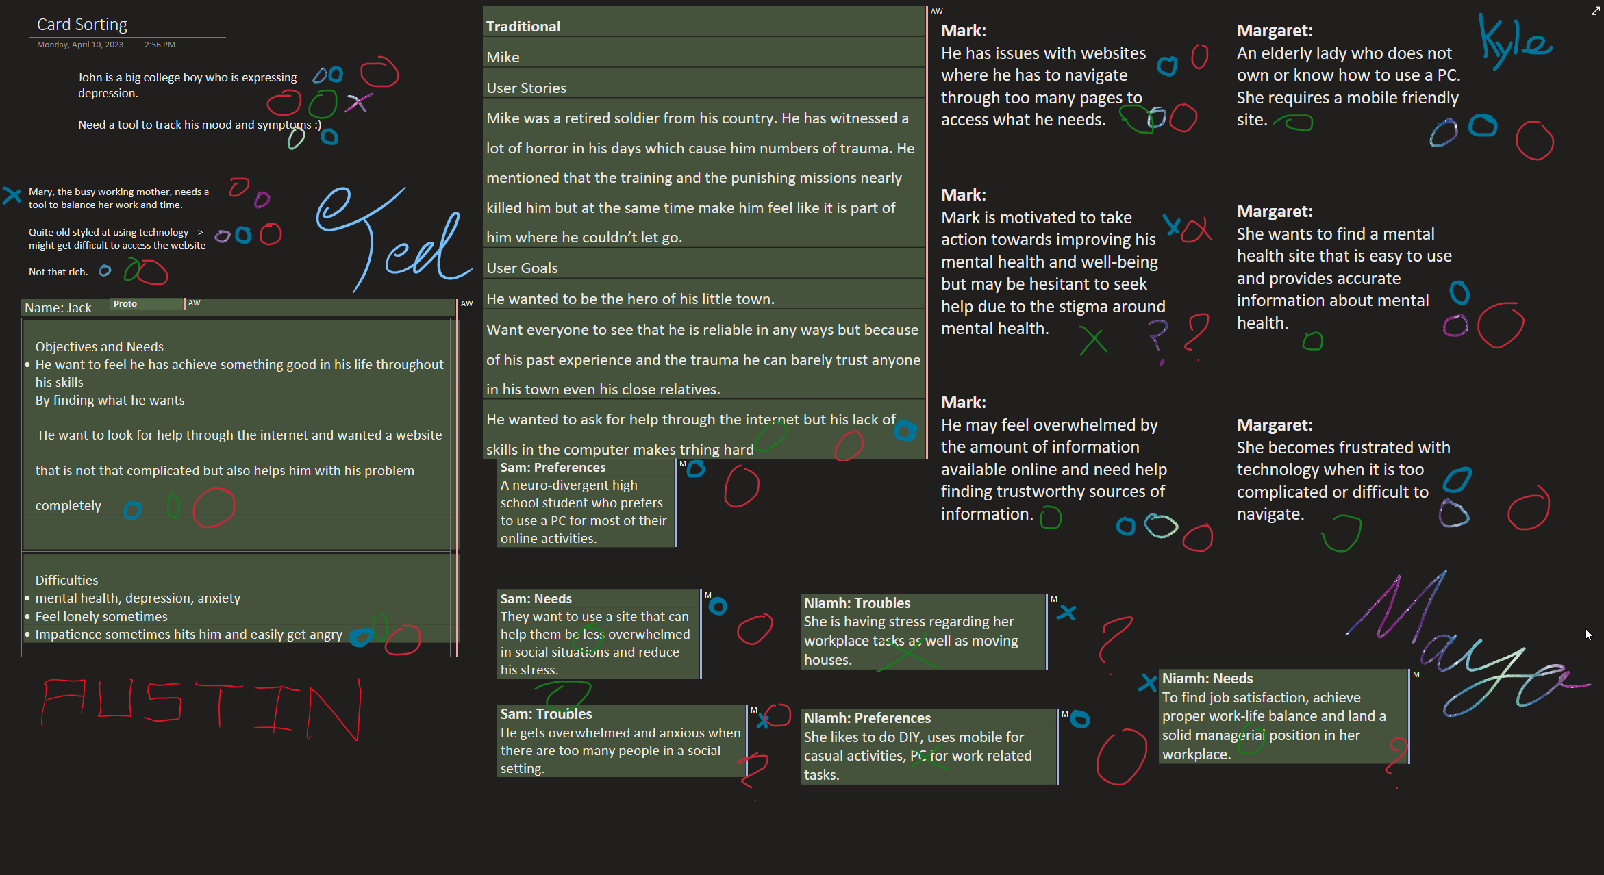In a group setting, we organised some of the needs and difficulties of our personas into a OneNote board. Here, we all decided to mark what was important/relevant for our domain by placing X’s for unusable or O’s for something that should be considered during the UX design. This will help us in further development during our group collaboration.

**Your design**

**MVP**My first MVP is an informative page that will provide the user with valuable information about mental health and the different conditions individuals can suffer from. This will contain cards that each give a brief description of specific mental health conditions. On clicking a card, information about the relevant condition will be displayed below the cards. This will reduce the number of pages to navigate through the site (a requirement for Mark). The site will be styled for compatibility with mobile devices and tablets. The aim will be for the cards to adjust in size with the resolutions to appear usable on these devices. Finally, the MVP will also include a basic footer and header for a more complete feel of the site. This is due to no skeleton being yet created for the domain.

**Information Architecture**

Unfortunately, due to some group members not developing ideas for their MVP until late, we could not combine our information architectures into a complete product. However, below is the information architecture for my MVP.

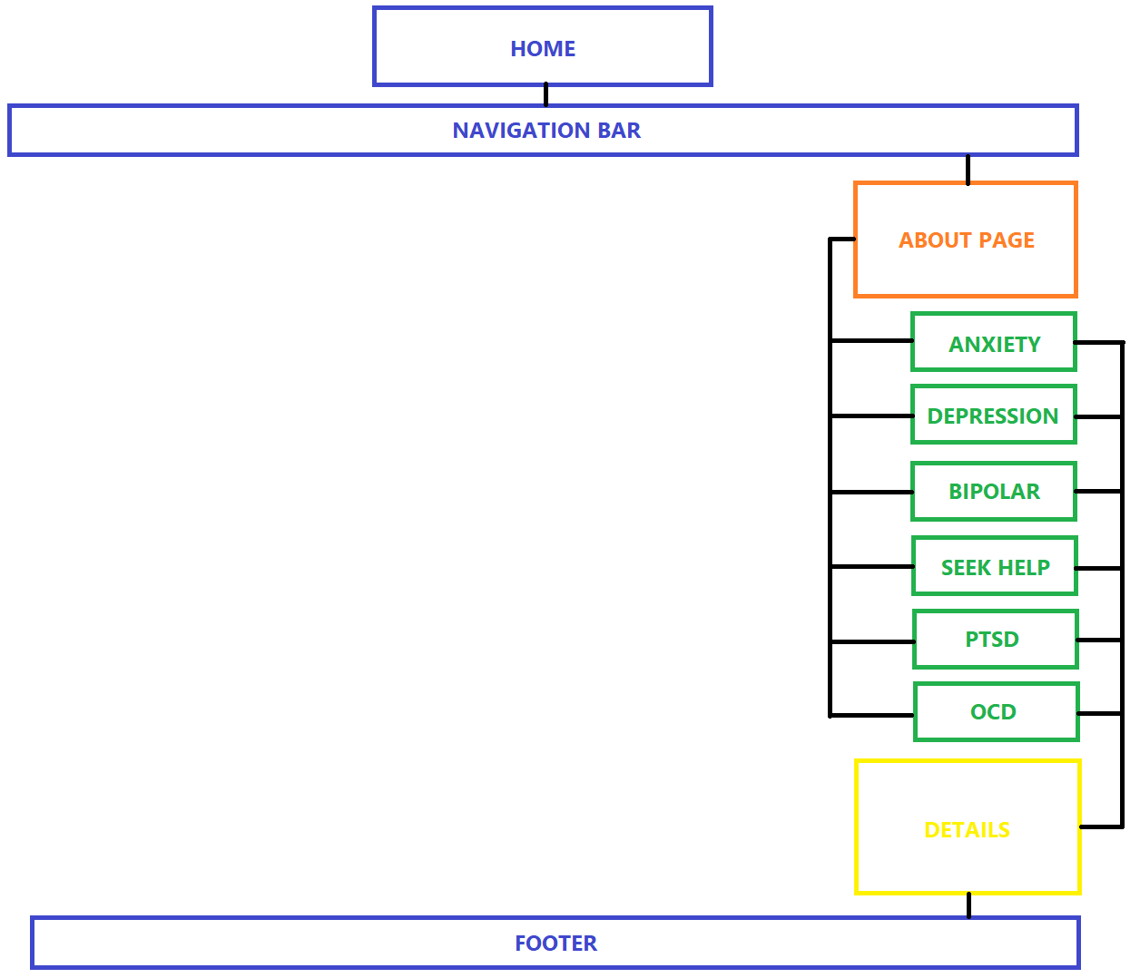

**LIVE SITE:** [**https://kyle226cards.bitbucket.io/**](https://kyle226cards.bitbucket.io/)